AI – Powered Synthetic Scenario Generator
In-House Project (7CS1900) REPORT

Submitted by

Akshata – 2023BCSE07AED389
Varshini J – 2023BCSE07AED403
Spandana Basava Kulal – 2023BCSE07AED441
Thrisha S – 2023BCSE07AED522

In partial fulfilment for the award of the degree of

BACHELOR OF TECHNOLOGY
In
COMPUTER SCIENCE AND ENGINEERING (AIML)

Under the Supervision of

Dr. Saswati Debnath

ALLIANCE SCHOOL OF ADVANCED COMPUTING
ALLIANCE UNIVERSITY, BENGALURU
NOVEMBER - 2026

ALLIANCE SCHOOL OF ADVANCED COMPUTING
ALLIANCE UNIVERSITY, BENGALURU
DEPARTMENT OF CSE (AIML)

----------------------------------------------------------------------------------------------------------

CERTIFICATE

This is to certify that the In-House Project work entitled “AI – Powered Synthetic Scenario Generator” is the bonafide work done by Akshata(2023BCSE07AED389), Varshini J(2023BCSE07AED403), Spandana Basava Kulal(2023BCSE07AED441), Thrisha S(2023BCSE07AEd522) submitted in partial fulfilment of the requirements for the award of the degree Bachelor of Technology in CSE during the year 2026

Dr. Saswati Debnath
Supervisor
Associate Professor
Dept. of CSE (AIML)



DECLARATION

This is to declare that the report titled “AI – Powered Synthetic Scenario Generator” has been made for the partial fulfilment of the Programme - Bachelor of Technology in Computer Science and Engineering, under the guidance of Dr. Saswati Debnath. We confirm that this report truly represents my work undertaken as a part of our In-House Project work. This work is not a replication of work done previously by any other person. We also confirm that the contents of the report and the views contained therein have been discussed and deliberated with the Mentor.

NAME | REGESTRATION NO. | SIGNATURE
Akshata | 2023BCSE07AED389
Varshini J | 2023BCSE07AED403
Spandana Basava Kulal | 2023BCSE07AED441
Thrisha S | 2023BCSE07AED522

ACKNOWLEDGEMENT

The satisfaction that accompanies the successful completion of the task would be put incomplete without the mention of the people that made it possible, whose constant guidance and encouragement crown all the efforts successfully.
We are very thankful to my supervisor Dr. Saswati Debnath for her sustained inspiring guidance and cooperation throughout the process of this project. Their wise counsel and valuable suggestions are invaluable.
We would like to thank Dr. K Rama Lakshmi, Head of the Department and Dr. V Vivek, Deputy Director, for their encouragement and cooperation at various levels of Project.
We avail this chance to express my deep sense of gratitude and hearty thanks to the Management of Alliance University, for providing world class infrastructure, congenial atmosphere, and encouragement.
We express my deep sense of gratitude and because of the teaching and non-teaching staff at our department who stood with me during the project and helped me to make it a successful venture.
We place highest regards to my parents, my friends and well-wishers who helped plenty in making the report of this project.

Akshata
Varshini J
Spandana Basava Kulal
Thrisha S

ABSTRACT
Network intrusion detection is essential for protecting computer networks from malicious activities. However, identifying less common cyberattacks is difficult because network datasets often contain many samples of some attack types and very few samples of others. This imbalance can make it harder for machine learning models to recognize rare attacks correctly.
This project presents an AI – Powered Synthetic Scenario Generator that explores the use of artificial data to improve the detection of underrepresented network attacks. The UNSW-NB15 dataset is used for the experiments. CTGAN is applied to generate 500 synthetic samples for the minority Worms attack category. These samples are added to the original training data, and a Random Forest classifier is trained using the augmented dataset. Its performance is then compared with a baseline model trained only on real data. Accuracy, precision, recall, F1-score, and confusion matrices are used to evaluate both models.
The results show that adding synthetic samples increased Worms recall from 0.2500 to 0.3571 and the Worms F1-score from 0.3889 to 0.4878. Overall accuracy changed slightly, from 0.9234 to 0.9237, while Worms precision decreased from 0.8750 to 0.7692. These findings suggest that synthetic data helped the model identify more Worms attacks, although this improvement came with a reduction in precision. A Streamlit dashboard was also developed to display synthetic samples, visualize evaluation metrics, and compare the performance of both models.
The project highlights the potential of synthetic data generation to improve the detection of rare network attacks. It also shows why intrusion detection models should be evaluated using minority-class metrics alongside overall accuracy.

LIST OF SYMBOLS & ABBREVIATIONS

Abbreviation | Full Form
AI | Artificial Intelligence
CTGAN | Conditional Tabular Generative Adversarial Network
GAN | Generative Adversarial Network
IDS | Intrusion Detection System
NIDS | Network Intrusion Detection System
ML | Machine Learning
RF | Random Forest
UNSW-NB15 | University of New South Wales Network-Based 2015 Dataset
TP | True Positive
TN | True Negative
FP | False Positive
FN | False Negative
GUI | Graphical User Interface
CSV | Comma-Separated
F1-score | Harmonic Mean of Precision and Recall
RAM | Random Access Memory
UI | User Interface
URL | Uniform Resource Locator

CONTENTS

Page No
Title Page 1
Certificate 2
Declaration 3
Acknowledgement 4
Abstract 5
List of Symbols & Abbreviations 6

Contents
- Introduction 8
- Literature Review 9-12
- Identification of the Problem / Scope of the Project 13
- Proposed Idea / Solution 14
- Objectives of the Idea / Solution 15
- Process/Methodology 16
  - Identify the needs of customer and users through Design Thinking Methods.
  - Translate the needs of customer into Project / Product.
  - Specification of the Project / Product
  - Designing the solution for the customer needs.
- Requirements 17
  - Hardware Requirements
  - Software Requirements
  - Datasets (If any)
  - Technologies and Tools
- Process / Flow / Design Diagram 18
- Proposed Modules 19
- Novelty of the Proposed Idea / Project 20
- Conclusion 21
References 17
Publication Proof ( Submission Copy) 19
Plagiarism Report 20

- INTRODUCTION
Today, computer networks and internet-based services are used in almost every filed, making network security increasingly important. Cyberattacks such as denial-of-service, reconnaissance, and other malicious activities can affect the safety and reliability of digital systems. Network Intrusion Detection Systems (NIDS) help monitor network traffic and identify activities that may indicate a security threat. Machine learning has become a useful approach for detecting suspicious network traffic. However, one challenge is that network datasets do not always contain an equal number of samples for each attack category. Common attacks may have many training examples, while rare attacks, such as Worms, may have very few. As a result, a model may perform well on common categories but fail to identify less frequent attacks.
This project, titled AI-Powered Synthetic Scenario Generator, explores the use of synthetic data to address this problem. The UNSW-NB15 dataset is used to train and evaluate the intrusion detection models. CTGAN (Conditional Tabular Generative Adversarial Network) is used to generate 500 artificial samples for the underrepresented Worms attack category. These samples are added to the original training data, and the performance of a Random Forest model trained on the augmented dataset is compared with a model trained using only real data.
Both models are evaluated using accuracy, precision, recall, F1-score, and confusion matrices. A Streamlit dashboard is also developed to display synthetic samples, visualize evaluation results, and compare model performance. The project examines whether generating additional samples for a rare attack category can help improve its detection and highlights the importance of evaluating minority-class performance alongside overall accuracy.

- LITERATURE REVIEW
Paper 1: Network Intrusion Detection Based on Balancing Generative Adversarial Network
Abstract:
This paper explores a Balancing Generative Adversarial Network (BAGAN-BD) to address class imbalance in network intrusion detection. The method generates additional attack samples and is evaluated on the UNSW-NB15 dataset.
Accomplishments and Limitations:
The study applies GAN-based synthetic data generation to improve the representation of underrepresented attack categories. However, its generator architecture is relatively complex, and targeted generation for one rare attack category can be explored further.
Scope:
It supports the idea of generating synthetic samples for minority attacks. Our project uses CTGAN to generate 500 Worms samples and compares Random Forest models trained on real-only and augmented data.

Paper 2: Enhancing Autonomous Intrusion Detection System with Generative Adversarial Networks
Abstract:
This work investigates GAN variants, including WGANGP, CGAN, CTGAN, and CWGANGP, for generating synthetic data for intrusion detection. It compares GAN-based augmentation with SMOTE and random oversampling using metrics such as accuracy, precision, recall, and F1-score.
Accomplishments and Limitations:
The study compares multiple GAN variants and conventional oversampling methods. However, using several generative models can increase computational complexity and training time.
Scope:
It informs the selection of CTGAN and supports our comparison of a real-only training dataset with a real-plus-synthetic dataset.

Paper 3: KiNETGAN: Enabling Distributed Network Intrusion Detection through Knowledge-Infused Synthetic Data Generation
Abstract:
KiNETGAN incorporates domain knowledge into GAN-based synthetic data generation. It aims to generate realistic synthetic network activity while considering privacy and class-imbalance issues in distributed IoT and cyber-physical-system environments.
Accomplishments and Limitations:
The work explores knowledge-informed synthetic network data for distributed intrusion detection. Its primary focus is IoT and cyber-physical systems rather than a specific rare attack category in UNSW-NB15.
Scope:
It supports investigating realistic synthetic network records and evaluating whether synthetic data improves minority-class detection.

Paper 4: AI-Driven Synthetic Test Data and Scenario Generation via GAN-LLM Integration: A Modular Approach for Web Application Testing
Abstract:
This study presents a modular test-data generation approach combining a large language model with generative models. It uses LLaMA4 for semantic extraction, CTGAN for tabular data, and SeqGAN for ordered interaction scenarios in web application testing.
Accomplishments and Limitations:
The approach combines language models with tabular and sequence generation. However, it is designed for web application testing rather than network intrusion detection using UNSW-NB15.
Scope:
It relates to the broader concept of synthetic scenario generation. Our project applies synthetic data generation specifically to network attack records.

Paper 5: An Enhanced AI-Based Network Intrusion Detection System Using Generative Adversarial Networks
Abstract:
This study uses Wasserstein GAN-based generation and an autoencoder-based intrusion detection component to create synthetic minority-attack traffic. The generated data is combined with reconstruction-error-based detection.
Accomplishments and Limitations:
The study explores GAN-based minority-attack generation and autoencoder-based detection. Its framework is more complex than a basic CTGAN augmentation pipeline.
Scope:
It provides background for using synthetic minority-class traffic. Our project evaluates a targeted CTGAN-plus-Random-Forest approach.

Paper 6: AE-Multi-WGAN: A Robust Multi-Attack Detection IDS for Imbalanced Datasets
Abstract:
This work proposes an ensemble approach combining an autoencoder with Multi-WGAN to generate synthetic attack samples and improve intrusion detection on imbalanced datasets, including UNSW-NB15.
Accomplishments and Limitations:
The study directly considers imbalanced intrusion detection and GAN-based sample generation. However, its ensemble architecture can be more computationally and technically complex than a targeted augmentation pipeline.
Scope:
It supports the motivation for synthetic attack generation and provides context for a CTGAN approach focused on the Worms category.

Paper 7: A Cost-Sensitive Machine Learning Model With Multitask Learning for Intrusion Detection in IoT
Abstract:
This study addresses low-frequency and unknown intrusions using cost-sensitive and multitask learning. It evaluates its approach on UNSW-NB15 and BoT-IoT datasets.
Accomplishments and Limitations:
The work explicitly addresses low-frequency and unknown intrusions. Its approach focuses on cost-sensitive and multitasks learning rather than synthetic sample generation.
Scope:
It supports our focus on rare attacks. Synthetic generation can be investigated as an alternative or complementary way to improve minority-class representation.

Paper 8: Enhanced Network Intrusion Detection Using a Hybrid CNN-LSTM Approach on the UNSW-NB15 Dataset
Abstract:
This paper uses a hybrid CNN-LSTM model for binary and multiclass intrusion detection on UNSW-NB15. It evaluates performance using accuracy, precision, recall, and F1-score.
Accomplishments and Limitations:
The study provides a deep-learning approach to intrusion classification on UNSW-NB15. It does not focus on using synthetic data to address minority-class imbalance.
Scope:
It supports the use of UNSW-NB15 and standard evaluation metrics. Our project examines whether CTGAN augmentation improves detection of the rare Worms category.

Paper 9: Network Anomaly Detection for Intrusion Detection Systems Using Q-Learning and Deep Q-Learning: A Reinforcement Learning Approach
Abstract:
This study applies Q-learning and deep Q-learning to adaptive intrusion detection. It uses UNSW-NB15 and simulates zero-day scenarios by excluding selected attack categories from training.
Accomplishments and Limitations:
The work explores adaptive detection and evaluation when selected attacks are absent from training. Its focus is reinforcement learning rather than generating synthetic minority-class records.
Scope:
It highlights the importance of evaluating rare or unseen attacks. Our project investigates whether synthetic samples improve learning for an underrepresented attack category.

Paper 10: Intrusion Detection System Based on Machine Learning Techniques: A Survey
Abstract:
This survey reviews machine-learning approaches and datasets for intrusion detection, including SVM, Random Forest, decision trees, Naïve Bayes, DNN, XGBoost, and others. It discusses datasets including UNSW-NB15 and compares methods using performance metrics.
Accomplishments and Limitations:
The survey provides broad background on intrusion detection algorithms, datasets, and evaluation measures. It does not deeply investigate GAN-based synthetic data generation.
Scope: It provides background for using Random Forest and standard evaluation metrics. Our project focuses on whether synthetic data can improve detection of rare attack classes.

3.IDENTIFICATION OF THE PROBLEM / SCOPE OF THE PROJECT
3.1 Identification of the Problem
Network intrusion detection systems help identify malicious activities in network traffic. However, detecting rare cyberattacks remains challenging because network datasets often contain an unequal number of samples across attack categories. When a particular attack has very few training samples, machine learning models may struggle to identify it correctly.
In the UNSW-NB15 dataset, the Worms attack category is underrepresented compared with several other classes. This imbalance can affect the model's ability to detect Worms attacks, even when its overall accuracy is high. Therefore, there is a need to explore techniques that increase the representation of minority attack categories and improve their detection. The main problem addressed in this project is whether synthetic data generation can improve the detection of rare network attacks without significantly affecting the overall performance of the classifier.
3.2 Scope of the Project
The project focuses on using synthetic data generation to address class imbalance in network intrusion detection. The UNSW-NB15 dataset is used to train and evaluate the classification models.
The scope of the project includes:
- Data preprocessing: Preparing network traffic records and features for machine learning.
- Synthetic data generation: Using Conditional Tabular Generative Adversarial Networks (CTGAN) to generate 500 synthetic samples for the minority Worms attack category.
- Model training: Training and comparing two Random Forest classifiers, one using only real training data and another using real training data combined with synthetic samples.
- Performance evaluation: Comparing the models using accuracy, precision, recall, F1-score, and confusion matrices.
- Dashboard development: Building an interactive Streamlit dashboard to display synthetic samples, visualize evaluation metrics, compare model performance, and present results.
The project is limited to the selected UNSW-NB15 dataset, the targeted Worms attack category, and the evaluated Random Forest models. It investigates the effectiveness of synthetic data augmentation in improving minority-class detection rather than claiming to provide a complete real-time intrusion prevention system.

4.PROPOSED IDEA / SOLUTION
The proposed solution is an AI-Powered Synthetic Scenario Generator designed to investigate the problem of class imbalance in network intrusion detection. The system uses the UNSW-NB15 dataset and focuses on improving the detection of the underrepresented Worms attack category through synthetic data generation.
The proposed approach uses Conditional Tabular Generative Adversarial Networks (CTGAN) to generate 500 synthetic Worms samples based on patterns learned from the original training data. These synthetic samples are combined with the real training data to increase the representation of the minority attack category. Two Random Forest classifiers are then trained: one using only real training data and the other using real and synthetic training data. Both models are evaluated on the same held-out test dataset using accuracy, precision, recall, F1-score, and confusion matrices. Their results are compared to determine whether synthetic data augmentation improves the detection of Worms attacks while maintaining overall classification performance. An interactive Streamlit dashboard is developed to present the workflow and experimental results. It provides visualizations of model performance, comparisons between the two classifiers, synthetic sample inspection, and downloadable results.
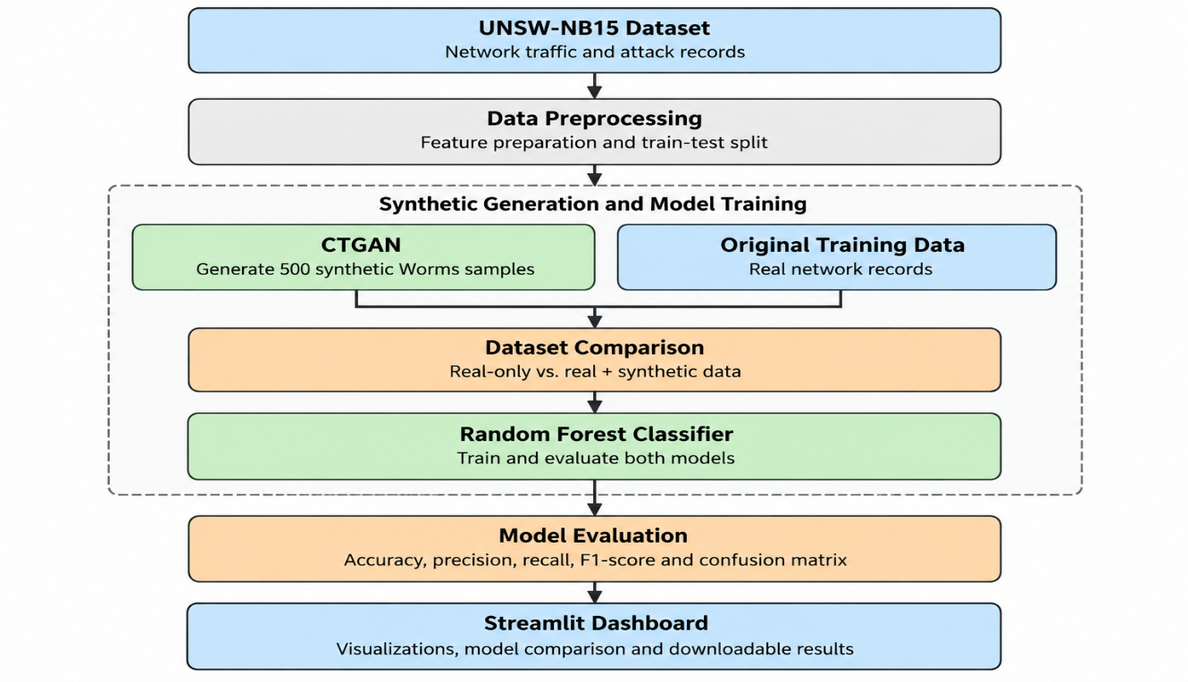
The main idea of the proposed solution is to explore whether generating additional samples for a rare attack category can help a machine learning model recognize that category more effectively. The effectiveness of the approach is assessed through experimental comparison rather than assuming that synthetic data will improve every evaluation metric.

Fig. 1. Proposed architecture of the AI-Powered Synthetic Scenario Generator.

5.OBJECTIVES OF THE IDEA / SOLUTION AS DESIGN PROJECT
The main objective of this project is to investigate the use of synthetic data generation to improve the detection of underrepresented cyberattacks in network intrusion detection systems.
The specific objectives are:
- To analyze class imbalance: Study the distribution of attack categories in the UNSW-NB15 dataset and identify the underrepresented Worms attack category
- To generate synthetic data: Use Conditional Tabular Generative Adversarial Networks (CTGAN) to generate 500 synthetic samples for the Worms attack category
- To train classification models: Develop Random Forest models using real training data and a combination of real and synthetic training data
- To compare model performance: Evaluate both models using accuracy, precision, recall, F1-score, and confusion matrices
- To assess minority-class detection: Investigate whether synthetic data augmentation improves the detection of Worms attack while examining its effect on other performance metrics
- To develop an interactive dashboard: Build a Streamlit application to visualize synthetic samples, display evaluation metrics, compare model performance and provide downloadable results
- To identify limitations and improvements: Analyze the experimental results and identify opportunities to improve synthetic data quality and minority-class detection in future work

6.PROCESS / METHODOLOGY

  - Identify the needs of customer and users through design thinking methods
Identify the challenges in network intrusion detection, particularly the difficulty of detecting rare cyberattacks due to class imbalance in the UNSW-NB15.

  - Translate the needs of customer into product / process / project
Propose an AI-Powered Synthetic Scenario Generator that uses CTGAN to generate additional samples for the underrepresented Worms attack category and investigate whether they improve detection performance.

  - Specification of the product / process / project
Use the UNSW-NB15 dataset, preprocess the network traffic records, generate 500 synthetic Worms samples, and train Random Forest classifiers using real-only and real + synthetic training data.

  - Designing the solution for required customer needs
Design workflow to generate synthetic data, compare both Random Forest models using accuracy, precision, recall, F1-score and confusion matrices, and display the results through an interactive Streamlit.

7.REQUIREMENTS
  - Hardware Requirements
- Processor: Intel Core i5 or equivalent and above
- RAM: Minimum 8 GB
- Storage: Minimum 10 GB of available disk space

  - Software Requirements
- Operating System: Windows / Linux
- Programming Language: Python
- Code Editor: VS code of or Jupyter Notebook
- Python libraries: Pandas, NumPy, Scikit-learn, CTGAN, Matplotlib, Seaborn
- Dashboard Framework: Streamlit

  - Datasets
- Dataset Name: UNSW-NB15
- Dataset Type: Network traffic and intrusion detection dataset
- Data Categories: Normal traffic and multiple cyberattacks categories, including Worms
- Purpose: Training and evaluating the intrusion detection models
- Synthetic Data: 500 generated Worms attack samples using CTGAN

  - Technologies and Tools
- Python: Implementation of data preprocessing, synthetic data generation and classification
- CTGAN: Generation of synthetic samples for the underrepresented Worms attack category
- Random Forest: Classification of network traffic into normal and attack categories
- Scikit-learn: Model training and performance evaluation
- Pandas and NumPy: Data manipulation and preprocessing
- Matplotlib and Seaborn: Visualization of evaluation metrics and confusion matrices
- Streamlit: development of the interactive dashboard for model comparison and result visualization

8.PROCESS / FLOW / DESIGN DIAGRAM
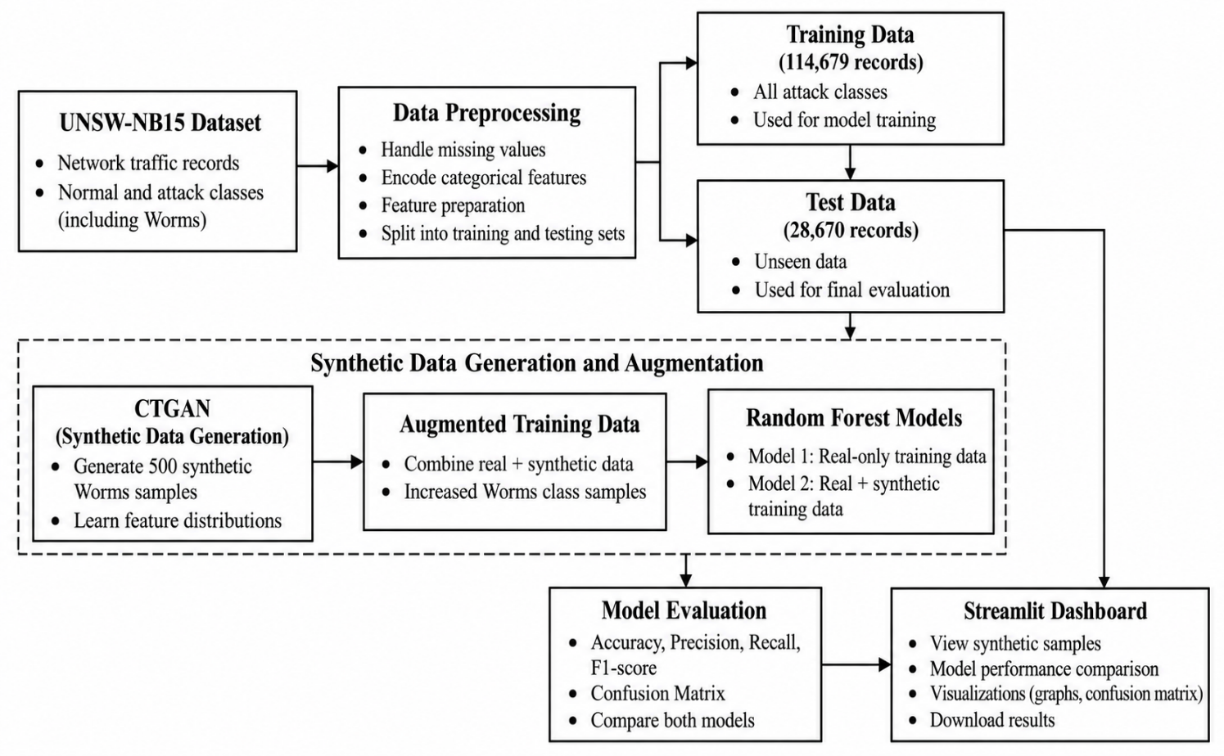
The following flow diagram illustrates the workflow of the proposed AI-Powered Synthetic Scenario Generator. It includes dataset preprocessing, synthetic Worms sample generation using CTGAN, Random Forest model training, performance evaluation and result visualization through the Streamlit dashboard.
Fig. 2. System architecture and workflow of the proposed AI-Powered Synthetic Scenario Generator.

The proposed system uses the UNSW-NB15 dataset, which contains normal network traffic and different types of cyberattacks. The dataset is pre-processed and divided into training and testing sets. CTGAN is then used to generate 500 synthetic samples for the underrepresented Worms attack category. These samples are combined with the original training data to create an augmented dataset.
Two Random Forest classifiers are trained: one using only real data and the other using real and synthetic data. Both models are evaluated on the same test dataset using accuracy, precision, recall, F1-score, and confusion matrices. Finally, a Streamlit dashboard displays the synthetic samples, visualizes evaluation metrics, and compares the performance of both models. This helps assess the impact of synthetic data generation on the detection of rare network attacks.

9.PROPOSED MODULES
The proposed system is divided into six modules, each responsible for a specific task in the network intrusion detection workflow. These modules cover dataset loading, data preprocessing, synthetic data generation, model training, performance evaluation, and dashboard development. Together, they help investigate the effectiveness of CTGAN-generated synthetic data in improving the detection of rare network attacks
- Dataset Loading Module – Loads the UNSW-NB15 dataset containing normal network traffic and different categories of cyberattacks, including Worms.
- Data Preprocessing Module – Handles missing values, encodes categorical features, prepares the data, and separates it into training and testing sets.
- Synthetic Data Generation Module – Use CTGAN to generate 500 synthetic samples for the underrepresented Worms attack category.
- Model Training Module – Trains two Random Forest classifiers: one using only real training data and another using real training data combined with synthetic samples.
- Model evaluation Module – Evaluates and compares both models’ using accuracy, precision, recall, F1-score and confusion matrices to analyze the effect of synthetic data augmentation.
- Streamlit Dashboard Module - Provides an interactive interface to view synthetic samples, visualize evaluation metrics, compare model performance, and download experimental results

10.NOVELTY OF THE IDEA / PROJECT
The novelty of this project lies in exploring targeted synthetic data generation to address class imbalance in network intrusion detection. Instead of relying only on the original training data, the proposed system uses CTGAN to generate 500 synthetic samples for the underrepresented Worms attack category in the UNSW-NB15 dataset.
The project compares a Random Forest model trained on real data with another trained on a combination of real and synthetic data. This comparison helps to analyze the effect of synthetic data augmentation on minority-class detection, particularly Worms recall and Fl-score. An interactive Streamlit dashboard further provides visualization of synthetic samples and models evaluation results.
Unlikely and approach that evaluates performance only through overall accuracy, this project also examines minority-class metrics to understand the benefits and trade-offs of synthetic data generation. The experimental results show improvements in Worms recall and F1-score, although precision decreases slightly in the augmented model.

11.CONCLUSION
The AI-Powered Synthetic Scenario Generator explores the use of synthetic data generation to address class imbalance in network intrusion detection. The project uses the UNSW-NB15 dataset and CTGAN to generate 500 synthetic samples for the underrepresented Worms attack category. Two Random Forest models are trained and compared using real-only and real + synthetic training data.
The experimental results show that synthetic data augmentation improved Worms recall from 0.2500 to 0.3571 and the Worms F1-score from 0.3889 to 0.4878. Overall accuracy increased slightly from 0.9234 to 0.9237, while Worms precision decreased. These findings indicate that synthetic data can help to improve the detection of certain minority-class attacks, although trade-offs between evaluation metrics remain.
An interactive Streamlit dashboard was developed to visualize synthetic samples, compare model performance, and display evaluation results. Overall, the project demonstrates the potential of CTGAN-based data augmentation for minority-class detection and highlights the importance of evaluating intrusion detection models using multiple performance metrics rather than overall accuracy alone.

REFERENCES
Conference Papers
[1] N. Moustafa and J. Slay, “UNSW-NB15: A comprehensive data set for network intrusion detection systems (UNSW-NB15 network data set),” in Proc. 2015 Military Communications and Information Systems Conference (MilCIS), 2015, pp. 1–6.
[2] L. Xu, M. Skoularidou, A. Cuesta-Infante, and K. Veeramachaneni, “Modeling tabular data using conditional GAN,” in Advances in Neural Information Processing Systems (NeurIPS), vol. 32, 2019.
[3] K. Kostage, D. West, T. Meinert, C. Qu, P. Calyam, and L. Mazzola, “Enhancing autonomous intrusion detection system with generative adversarial networks,” in Proc. IEEE International Conference on e-Science, 2024.

Journal Articles
[4] N. Moustafa and J. Slay, “The evaluation of network anomaly detection systems: Statistical analysis of the UNSW-NB15 data set and the comparison with the KDD99 data set,” Information Security Journal: A Global Perspective, vol. 25, nos. 1–3, pp. 18–31, 2016.
[5] C. Park, J. Lee, Y. Kim, J.-G. Park, H. Kim, and D. Hong, “An enhanced AI-based network intrusion detection system using generative adversarial networks,” IEEE Internet of Things Journal, vol. 10, no. 3, 2023.

Online Resources
[6] Australian Centre for Cyber Security, “The UNSW-NB15 Dataset.” [Online]. Available: https://research.unsw.edu.au/projects/unsw-nb15-dataset
[7] Streamlit, “Streamlit Documentation.” [Online]. Available: https://docs.streamlit.io/
[8] DataCebo, “CTGAN: Modeling Tabular Data Using Conditional GAN.” [Online]. Available: https://github.com/sdv-dev/CTGAN

Proof (Submission Copy)

PLAGIARISM REPORT

